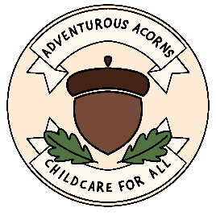
Medication Policy and Procedures
At Adventurous Acorns we promote the good health of children in our care. If you child requires medicine, we will obtain information about the child's needs for this and will ensure this information is kept up to date. I am fully qualified to administer medication.

Medication prescribed by a doctor, dentist, nurse, or pharmacist.
- Prescription medicine will only be given to the person named on the bottle for the dosage stated.
- Medicines must be in their original containers.
- Those with parental responsibility for any child requiring prescription medication should hand over the medication to me or inform me of where it is kept, then note the details for administration.
​
Non-prescription medication.
- If your child needs to take non-prescribed medication i am happy to administer this to them (eg Calpol for teething, creams for skin conditions, everyday vitamins)
All medication administered will be recorded in our Medication Record File, with the following information provided:
- Name of Child, DOB
- Date and Time
- Amount of medicine administered
- Signed by both Arden Nolan-Meharg and Parent/ guardian of child.

Signed: Arden Nolan-Meharg
Date: 11/06/2023

